|  |  |  |
| --- | --- | --- |
| |  |  | | --- | --- | |  |  | |
| **<Hospital>** |
| **Functional Specification Design Document** |
|  |

|  |  |  |
| --- | --- | --- |
| Author | : | * Muhammad Randy Maulana * Rena Dian Puspita * Nuzul Fithra Ryaldi |
| Version | : | 1.0 |
| Last Update | : | 10.8.2022 |
| Total Page Count | : | -- |

**Copyright © 2016 Jatis Solutions. All rights reserved. These materials are confidential and proprietary to Jatis Solutions and no part in these materials should be reproduced, published in any form by any means, electronic or mechanical including photocopy or any information storage or retrieval system nor should the materials be disclosed to third parties without the express written authorization of Jatis Solutions.**

**Version History**

| **Version** | **Date** | **By** | **Change Summary** |
| --- | --- | --- | --- |
| -- | -- | -- | * Initial Draft |
|  |  |  |  |
|  |  |  |  |
|  |  |  |  |
|  |  |  |  |
|  |  |  |  |

**Table of Contents**

1. Introduction 5

1.1. Purpose 5

1.2. Convention 5

1.2.1. Field Type 5

1.2.2. Data Type 5

1.2.3. Field Status 6

1.2.4. Controls Type 6

2. Functional Design 7

**Table of Figures**

**Figure 1- Page Add Fee Structure** 9

**Figure 2 - Page Add Fee Structure** 10

**Figure 3 - Page Edit Fee Structure** 11

**Figure 4 - Page View Fee Structure** 12

**Figure 5 - Flow Pengenaan Channel Fee** 14

**Figure 6 - Page Submit Buy** 17

**Figure 7 - Page Submit Sell** 19

**Figure 8 - Page Confirm Submit Buy** 20

**Figure 9 -Page Confirm Submit Sell** 21

**Figure 10 - Page Outgoing Task Buy** 23

**Figure 11 - Page Outgoing Task Sell** 24

**Figure 12 - Page Approval Buy** 26

**Figure 13 - Page Approval Sell** 27

**Figure 14 - Page Resubmit Buy** 29

**Figure 15 - Page Resubmit Sell** 30

**Figure 16 - Page Confirm Resubmit Buy** 32

**Figure 17 -Page Confirm Resubmit Sell** 33

**Figure 18 - Flow Perhitungan setelah Reconcile Murex** 44

**Figure 19 - Parameter Report Transaction History** 61

**Figure 20 - Parameter Report Transaction Status** 65

**Table of Tables**

**Table 1 - Table Field Type** 6

**Table 2 - Table Data Type** 7

**Table 3 -Table Field Status** 7

**Table 4 -Table Controls Type** 7

**Table 5 - Spesifikasi Enhancement Field Page Add** 10

**Table 6 - Spesifikasi Enhancement Field Page Edit** 12

**Table 7 - Spesifikasi Enhancement Field Page View** 13

**Table 8 - Rumus Net Amount** 15

**Table 9 - Rumus Settlement Amount** 15

**Table 10 - Spesifikasi Enhancement Field Page Submit Buy** 18

**Table 11 - Spesifikasi Enhancement Field Page Submit Sell** 19

**Table 12 - Spesifikasi Enhancement Field Page Confirm Submit Buy** 21

**Table 13 - Spesifikasi Enhancement Field Page Confirm Submit Sell** 22

**Table 14 - Spesifikasi Enhancement Field Page Outgoing Task Buy** 23

**Table 15 - Spesifikasi Enhancement Field Page Outgoing Task Sell** 25

**Table 16 - Spesifikasi Enhancement Field Page Approval Buy** 26

**Table 17 - Spesifikasi Enhancement Field Page Approval Sell** 28

**Table 18 - Spesifikasi Enhancement Field Page Resubmit Buy** 29

**Table 19 - Spesifikasi Enhancement Field Page Resubmit Sell** 31

**Table 20 - Spesifikasi Enhancement Field Page Confirm Resubmit Buy** 32

**Table 21 - Spesifikasi Enhancement Field Page Confirm Resubmit Sell** 34

**Table 22 - Penambahan Validasi API Transaksi FI** 35

**Table 23 - Spesifikasi Request API Buy** 37

**Table 24 - Spesifikasi Response API Buy** 37

**Table 25 - Sampel dan Request API Buy** 37

**Table 26 - Spesifikasi Request API Sell** 39

**Table 27 - Spesifikasi Response API Sell** 39

**Table 28 - Sample dan Response API Sell** 40

**Table 29 - Perubahan Integrasi Transaksi Buy** 41

**Table 30 - Kondisi Existing Integrasi** 42

**Table 31 - Perubahan Integrasi Transaksi Sell** 42

**Table 32 - Perubahan Integrasi Transaksi API** 43

**Table 33 - Spesifikasi Request API FI Acrrued** 53

**Table 34 - Spesifikasi Response API FI Acrrued** 54

**Table 35 - Sample Request dan Response API FI Accrued** 55

**Table 36 - Spesifikasi Request API FI Transaction History** 56

**Table 37 -Spesifikasi Response API FI Transaction history** 59

**Table 38 - Sample Request dan Response API FI Transaction history** 60

**Table 39 - Field Descriptions Parameter Repost Transaction History** 62

**Table 40 - Action Controls Parameter Repost Transaction History** 62

**Table 41 - Field Description Report Transaction History** 64

**Table 42 - Field Description Parameter Report Transaction Status** 66

**Table 43 - Action Controls Parameter Report Transaction Status** 67

**Table 44 - Field Description Report Transaction Status** 68

**Table 45 - Spesifikasi Request API FI List Product** 71

**Table 46 - Spesifikasi Response API FI List Product** 73

**Table 47 - Sample Request and Response API FI List Product** 74

# Introduction

## Purpose

Dokumen ini bersifat sebagai dokumen addendum dari VO yang telah disepakati, yang tercantum dalam dokumen ini hanyalah perubahan-perubahan yang terjadi terhadap aplikasi. Dokumen ini dibuat berdasarkan dokumen VO.

## Convention

Berikut beberapa istilah yang digunakan dalam dokumen ini

### Field Type

|  |  |
| --- | --- |
| **Abbreviation** | **Description** |
| TSL | Textbox Single Line |
| TML | Textbox Multiple Line |
| DDL | Dropdown List |
| CKB | Check Box |
| RDB | Radio Button |
| LBL | Label |
| DPL | Date Pick List  calendar |
| SCH | Search  search |

**Table 1 - Table Field Type**

### Data Type

|  |  |
| --- | --- |
| **Abbreviation** | **Description** |
| NUM (<length>,<decimal length>) | Numeric |
| APB (<length>) | Alphabet |
| APN (<length>) | Alphanumeric |
| DTE | Date |
| DTM | Date and Time |

**Table 2 - Table Data Type**

### Field Status

|  |  |
| --- | --- |
| **Abbreviation** | **Description** |
| M | Mandatory |
| O | Optional |
| D | Display |
| C | Sistem calculated |

**Table 3 -Table Field Status**

### Controls Type

|  |  |
| --- | --- |
| **Abbreviation** | **Description** |
| BTN | Button  button |
| HYP | Hyperlink  View | Edit |
| TAB | Tab |

**Table 4 -Table Controls Type**

# Functional Design

## System Overview

System di bentuk untuk memudahkan rumah sakit untuk menginput,dan memberikan treatments pada pasien,sehingga rumah sakit berjalan dengan lebih efisien serta memiliki data dalam bentuk digital

## Halaman Login

Dihalaman ini berfungsi untuk menginput username dan password,yang dimiliki user untuk bias mengakses halaman lain.

### Use Case

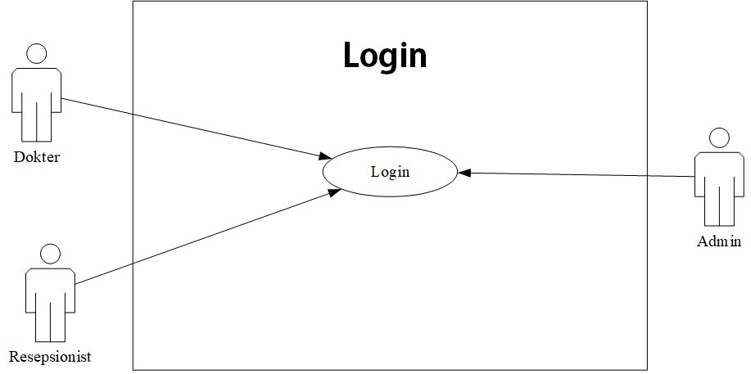

### Activity Diagram

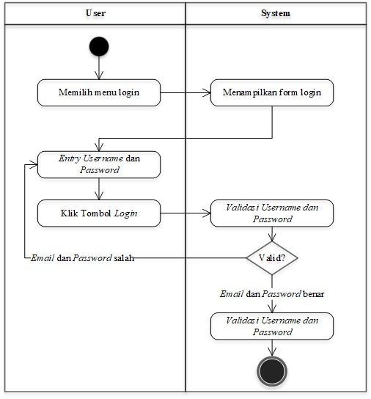

### User Interface

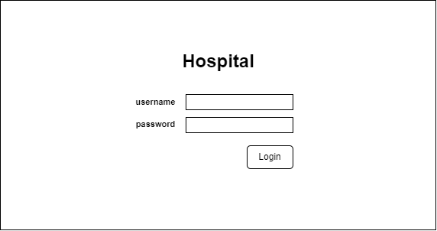

### Field Description`

|  |  |  |  |  |
| --- | --- | --- | --- | --- |
| No | Nama Field | Type | Size | Keterangan |
| 1 | User Name | APN | 255 | Untuk kebutuhan login dari setiap users Hospital |
| 2 | Password | APN | 255 | Untuk kebutuhan login dari setiap users Hospital |

### Action Control

|  |  |  |
| --- | --- | --- |
| **Abbreviation** | **Description** | **Action** |
| BTN | Button | if (role == "USER_TYPE_ADMIN") {                  navigate("/SuperAdmin");              } else {                  navigate("/Doctors");              } |

## Halaman LandingPage Super Admin

### Use Case

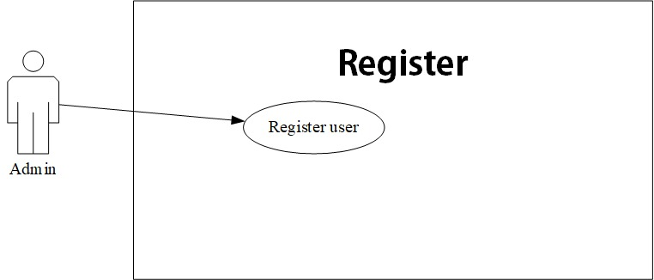

### Activity Diagram

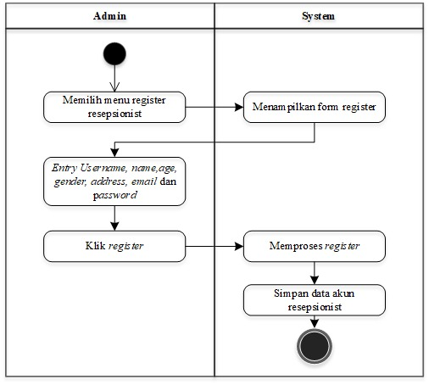

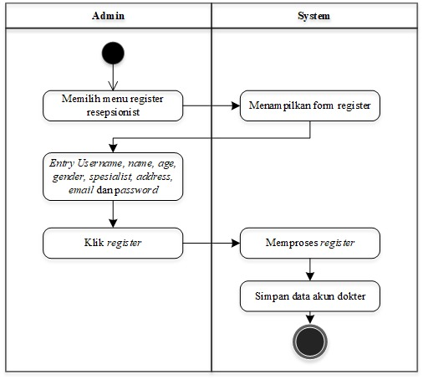

### User Interface

### Field Description

### Action Control

|  |  |  |
| --- | --- | --- |
| **Abbreviation** | **Description** | **Action** |
| BTN | Button | /EditUser |
| BTN | Button |  |

## Halaman Register

### Use Case



### Activity Diagram



### User Interface

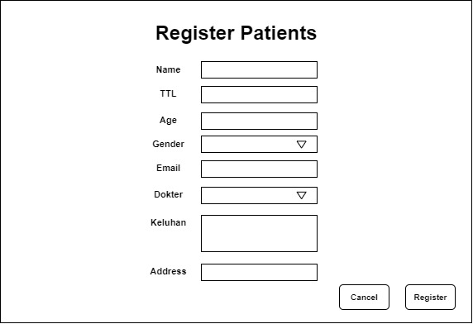

### Field Description

### Action Control

|  |  |  |
| --- | --- | --- |
| **Abbreviation** | **Description** | **Action** |
| BTN | Button | navigate("/SuperAdmin"); |

## Halaman LandingPage Doctor

### Use Case

### Activity Diagram

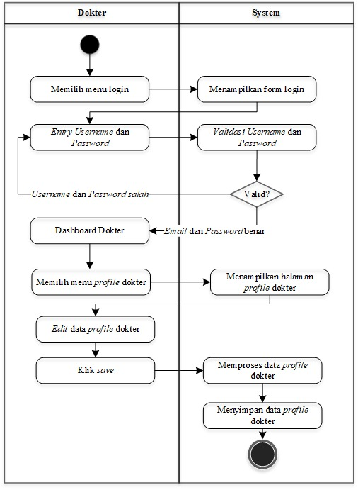

### User Interface

### Field Description

### Action Control

## Halaman Register Treatments

### Use Case

### Activity Diagram

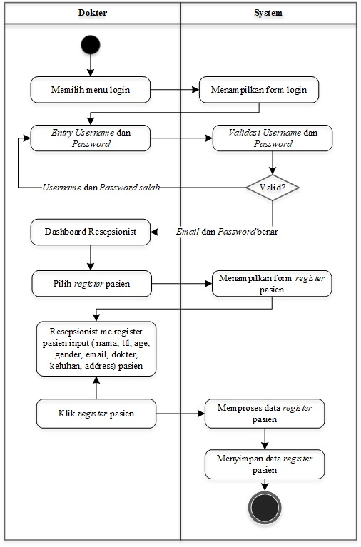

### User Interface

### Field Description

### Action Control

## Halaman View Patients

### Use Case

### Activity Diagram

### User Interface

### Field Description

### Action Control

## Halaman Giving Treatments

### Use Case

### Activity Diagram

### User Interface

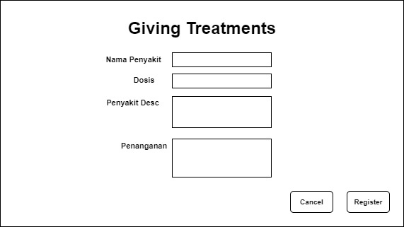

### Field Description

### Action Control

## Halaman LandingPage Receptionist

### Use Case

### Activity Diagram

### User Interface

### Field Description

### Action Control

## Halaman Daftar Pasien

### Use Case

### Activity Diagram

### User Interface

### Field Description

### Action Control

## Halaman Register Pasien

### Use Case

### Activity Diagram

### User Interface



### Field Description

### Action Control

## Halaman LandingPage Patients

### Use Case

### Activity Diagram

### User Interface

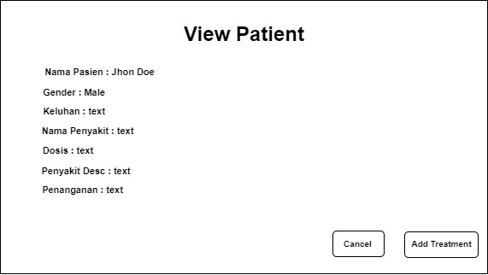

### Field Description

### Action Control

## Halaman HomePage Patients

### Use Case

### Activity Diagram

### User Interface

### Field Description

### Action Control